Lab 6 - Arrays

Assigned Textbook Problems - Chapter 8 – Arrays
- Problem # 1, page 333
- Problem # 3, page 333
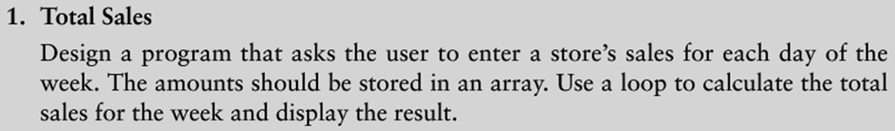
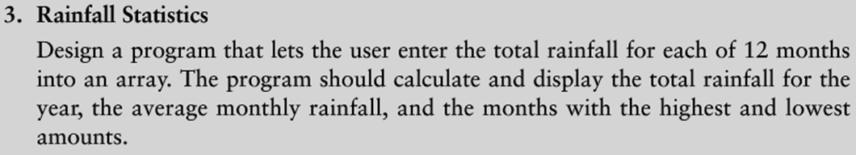

Problem # 1 – Total Sales

Requirements: Problem 1 - page 333
- Submit the pseudo code
- Submit the Python code for the problem

Objectives: Problem 1 - page 333
The objectives of this lab exercise are to:
- Write the out the pseudo code needed to solve this problem.
- Solve the problem through a Python programming solution.
  - Add comments to describe the purpose for each function.
  - Refer to the Python 3 Language Companion for the Gaddis textbook.
  - Review the video notes provided on the publisher website.
  - Refer to sections 8.3 on hints for totaling values in an array.
  - Copy & paste the program output, and place after the program code.
- Use a loop to calculate the total sales for a week, and to display the results.
- Use an Array to store the sales for each day of the week.
- Use functions with return statements.

(15 pts.) Pseudo code: Problem 1 - page 333
- Write the pseudo code.
- Refer to Appendix C on page 589, Programming Logic and Design textbook.
  - Pseudo code reference pages 589 - 599

(35 pts.) Python code: Problem 1 – page 333
- Select either IDLE, MS Visual Studio 2013 or Eclipse for Python 3.4.1.
  - Select the Python IDE that works best for you!
- Write the Python source code based on your pseudo code.

#=============================================================
# Course-Lab: CS104 – Lab 6, Arrays – Total Sales
# Filename: Lab_6_ Arrays_TotalSales.py
# Author: <Your name>
# Purpose: <Write out your own purpose problem 5. >
#=============================================================

Deliverable(s): Problem 1 – page 333
- Hand in the printed Python source code.
  - Test the program three times.
  - Include the outputs from running the code by pasting into the source code.
    - Use triple sets of quotes around the output.
- Hand in the pseudo code for this problem.
- Submit electronic versions of the lab file.
  - .py file
  - Flow chart or pseudo code

Problem # 3 – Rainfall Statistics

Requirements: Problem 3 - page 333
- Submit the pseudo code
- Submit the Python code for the problem

Objectives: Problem 3 - page 333
The objectives of this lab exercise are to:
- Write the out the pseudo code needed to solve this problem.
- Solve the problem through a Python programming solution.
  - Add comments to describe the purpose for each function.
  - Refer to the Python 3 Language Companion for the Gaddis textbook.
  - Refer to chapter 8 on Arrays.
  - Copy & paste the program output, and place after the program code.
- The user should enter the total rainfall for each month by using an array.
- Use functions with return statements.

(15 pts.) Pseudo code: Problem 3 - page 333
- Write the pseudo code.
- Refer to Appendix C on page 589, Programming Logic and Design textbook.
  - Pseudo code reference pages 589 - 599

(35 pts.) Python code: Problem 3 - page 333
- Select either IDLE, MS Visual Studio 2013 or Eclipse for Python 3.4.1.
  - Select the Python IDE that works best for you!
- Write the Python source code based on your pseudo code.

#=============================================================
# Course-Lab: CS104 – Lab 6, Arrays – Rainfall Statistics
# Filename: Lab_6_ Arrays_RainfallStats.py
# Author: <Your name>
# Purpose: <Write out your own purpose problem 5. >
#=============================================================

Deliverable(s): Problem 3 - page 333

- Hand in the printed Python source code.
  - Test the program three times.
  - Include the outputs from running the code by pasting into the source code.
    - Use triple sets of quotes around the output.
- Hand in the pseudo code for this problem.
- Submit electronic versions of the lab file.
  - .py file
  - Flow chart or pseudo code

